Neural Networks

Deep learning is a supervised ML algorithm that uses deep neural networks [nn with more than two layers] as its model. Artificial neural networks (ANNs) are comprised of a node layers, containing an input layer, one or more hidden layers, and an output layer. Each node, or artificial neuron, connects to another and has an associated weight and threshold. If the output of any individual node is above the specified threshold value, that node is activated, sending data to the next layer of the network. Otherwise, no data is passed along to the next layer of the network.

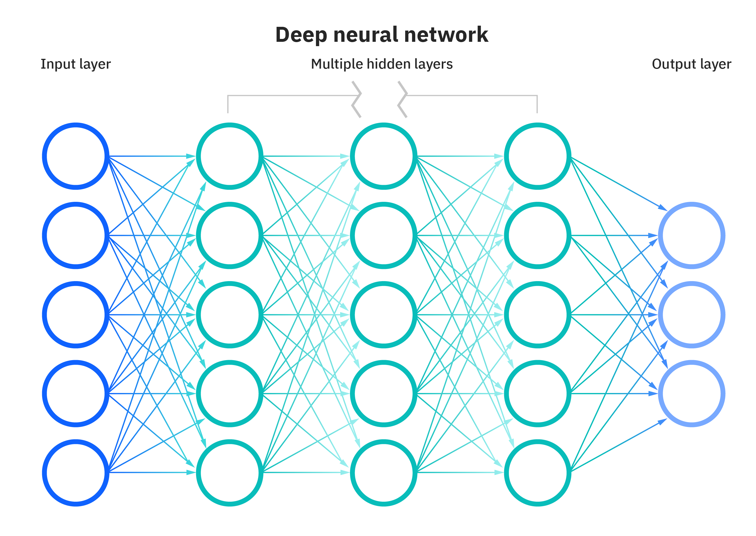

#### Activation function

The **activation function** is a mathematical operation that is applied to the output of a neuron before it is passed on to the next neuron. The activation function determines how the neuron will respond to its inputs. Some activation functions are:

1. Sigmoid function: **f(z) = 1/(1+e-z)**
2. Linear function : **f(z) = z.** (or ‘no function’).
3. ReLu (Rectified linear activation function): **f(z) = max(0,z).** Preferred in hidden layers.

#### Forward Propogation

As the input is passed from one layer to another, it is multiplied by the weight and added to bias. Then the whole thing is passed to an activation function before passed on to the next layer. The activation function determines if the neuron is activated for the next layer. Generally ReLu is used for hidden layer and sigmoid(or softmax) for the last(output) layer for classification.

For each layer l ,if g is the activation function,

fl(**X**) = g( **Wl.X** + bl)

So, the whole NN would look like

fnn(X) = f1(f2(f3(X)))

This whole process where the input propogates through the different layers to the output layer to perform inference is called forward propogation.

If we want to solve a regression or a classification problem discussed in previous chapters, the last (the rightmost) layer of a neural network usually contains only one unit. If the activation function glast of the last unit is linear, then the neural network is a regression model. If the glast is a logistic function, the neural network is a binary classification model.

#### Backpropogation

Training is the process by which a neural network eats the data, and updates its parameters such that the model transforms the input data to output. Backpropogation is a popular algorithm for updating the paramters of a model. It uses gradient descent to calculate the direction in which the weights should be adjusted. The negative of the gradient points in the direction of the steepest descent.

The backpropagation algorithm works as follows:

1. The network propagates the input data forward through the network, calculating the output of neural network. The error between the network's output and the target is used to form a loss function, and eventually a **cost function.**
2. This partial derivative of the cost function is calculated with respect to each parameter. The negative gradient of the cost function points in the direction of steepest descent, which helps to minimize the cost function.
3. The network's parameters are updated using the gradients. The learning rate, a hyperparameter, is multiplied by the gradient to determine the step size. This step size controls the rate at which the parameters are adjusted. One iteration of backpropagation involves updating the parameters based on the calculated gradients. An epoch consists of multiple iterations, where each iteration updates the parameters using a different batch of data.

#### Exploding and Vanishing gradients

Exploding and vanishing gradients are issues that can occur during the training of deep neural networks, particularly those with many layers. These problems are related to the way gradients are propagated backward through the network during the backpropagation process.

**Exploding Gradients:** When gradients grow exponentially as they are propagated backward through the layers of a deep neural network, it's referred to as the "exploding gradients" problem.As the gradients become extremely large, parameter updates can also become very large, causing the network's parameters to change significantly in each iteration. This can lead to instability in training, making it difficult for the network to converge to a good solution.

**Vanishing Gradients:** This often happens when the network has many layers, particularly in networks with activation functions that squash their inputs. As gradients become smaller and smaller, the updates to the parameters become insignificant, and the network learns at an extremely slow pace. This can lead to early layers of the network not learning effectively, resulting in poor overall performance.

# Types of Neural Networks

#### Multilayer Perceptrons

They look like basic NNs.

#### Convolutional Neural Network

A convolutional neural network (CNN) is a special kind of feed forward NN*[a type of artificial neural network in which the connections between the neurons do not form a cycle and the information in the network flows in only one direction, from the input layer to the output layer]* that significantly reduces the number of parameters in a deep neural network with many units without losing too much in the quality of the model. It generally takes input in matrix form and was designed to work on image processing, as an image consists of block of information as a chunk.

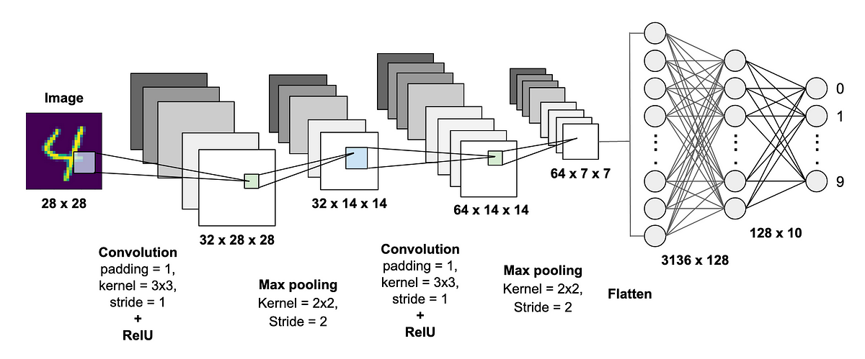

A CNN typically has three layers: **convolutional layer**, **pooling layer**, and **fully connected layer**. These layers work together to learn patterns and edges in input data(images).

**Convolution Layer**

The convolution layer is the core building block of the CNN. It carries the main portion of the network’s computational load. This layer performs a dot product between two matrices, where one matrix is the set of learnable parameters otherwise known as a **kernel,** and the other matrix is the restricted portion of the input from the previous layer. The kernel is spatially smaller than an image but is more in-depth (to handle color channels).

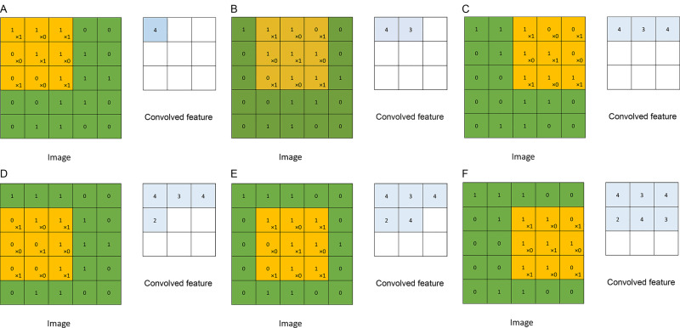

During the forward pass, the kernel slides across the height and width of the image-producing the image representation of that receptive region. This produces a two-dimensional representation of the image known as an activation map that gives the response of the kernel at each spatial position of the image. The sliding size of the kernel is called a **stride**.The whole process of matrix multiplying the bigger matrix with the filter is called **convolution.**

**Pooling Layer**

The pooling layer replaces the output of the network at certain locations by deriving a summary statistic of the nearby outputs. This helps in reducing the spatial size of the representation, which decreases the required amount of computation and weights. This vastly increases performance.The most popular pooling process is max pooling, which reports the maximum output from the neighborhood.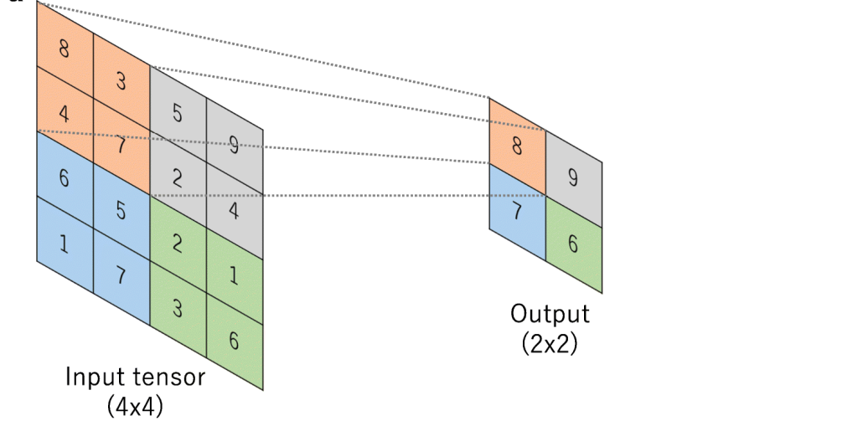 Pooling layers reduce the spatial dimensions of the feature maps, helping to decrease computational complexity and control overfitting.

**Fully Connected Layer**

Neurons in this layer have full connectivity with all neurons in the preceding and succeeding layer as seen in regular FCNN. This is why it can be computed as usual by a matrix multiplication followed by a bias effect. The FC layer helps to map the representation between the input and the output.

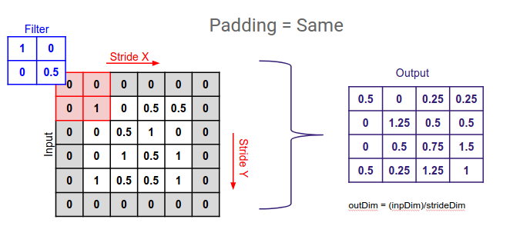

**Padding**

Padding allows getting a larger output matrix,after covolution is performed. The cells added by padding usually contain zeroes.

**Working of CNN on image data**

1. The input is consumed by the model as matrix. This matrix is composed of pixel values that correspond to the intensity of light at different positions in the image. This is passed into the CNN.
2. The CNN will have convolutional layer, which will perform convolution of the input with filter. This can be passed into pooling and fully connected layers. A CNN can have multiple of each layers. Usually, a pooling layer follows a convolution layer, and it gets the output of convolution as input.
3. The very last FC layer is often followed by a classification layer, which is typically a softmax layer for classification tasks. This layer computes the probability distribution over different classes based on the learned features from the preceding layers.

#### Recurrent Neural Network

RNNs are used to classify or generate **sequencial data** – data where the order of the data have importance. Also, RNNs are able to handle (sequencial) input of varying number. ie, it will perform even if there are 1000 data or 20 data for inference. Because of the sequencial nature, RNNs are used in text processing.

This is possible because RNNs take in input in a sequential format, and not ‘all in one go’. RNNs are able to keep track of the sequence because of the **feedback loop** present in it - thus RNNs are not feed forward NNs. These feedback loops allow them to maintain a hidden state representing information from previous time steps in the sequence.

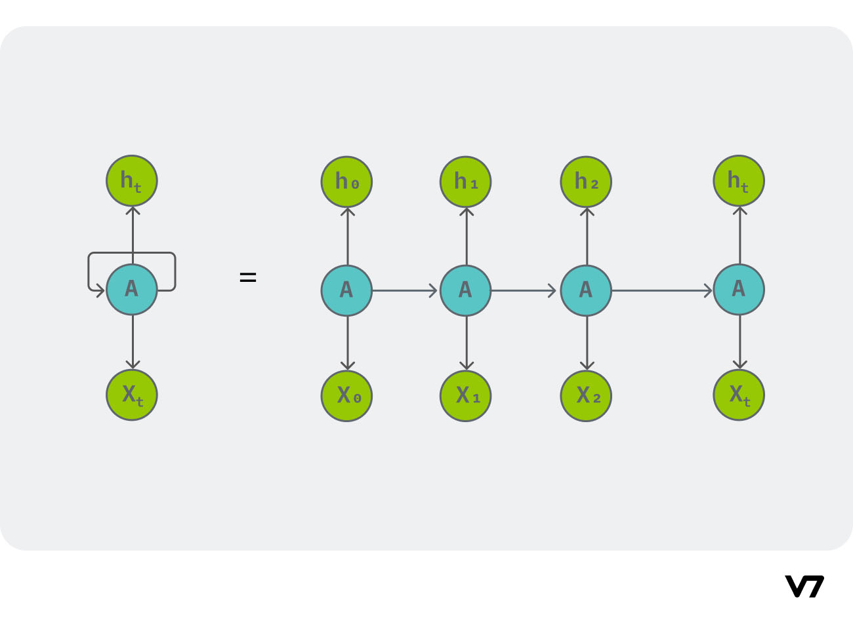

Each recurrent layer in an RNN takes two inputs – one is the input coming into the from the earlier layer, and the other is the output of the same layer from the previous data. RNNs use a variation of backpropagation called **Backpropagation Through Time** (BPTT) to update the model's weights and biases. BPTT involves computing gradients through the entire sequence and updating the model parameters accordingly.

The major problems faced by RNNs are:

1. Exploding and vanishing gradients
2. As the length of the input sequence grows, the feature vectors from the beginning of the sequence tend to be “forgotten,” because the state of each unit, which serves as network’s memory, becomes significantly affected by the feature vectors read more recently.

**LSTM (Long Short-Term Memory) networks** were specifically designed to address both the exploding and vanishing gradient problems as well as the long-term dependencies issue, making them a significant improvement over vanilla RNNs in these aspects.

LSTM networks have two kinds of memory – short and long term memory. Both of these together help in the inference.

The first stage of LSTM unit determines how much of the long term memory is to be remembered, and is called forget gate. The rest of the units combines their short term memory to create a long term memory.

Then there is input gate. **Learn later.**